Z Method

Architecture: [1024, 1024, 1024, 1024]

Interpolation:

Emulated the lnk’s at all 10 z’s for each set of input parameters (with 10 emulations), then interpolated between the z’s to find the exact lnk at the required z

Time to calculate: 0.4447 ± 0.0825 seconds

The mean percentage difference between the interpolated value and true value: 12.977 ± 9.238%

Grid Method

NEAT Architecture

Architecture: [256]

Interpolation:

Emulated the lnk’s at all 10 z’s for each set of input parameters (with 1 emulation), then interpolated between the z’s to find the exact lnk at the required z

Time to calculate: 0.017701515909991486 +- 0.004370823415461956 seconds

The mean percentage difference between the interpolated value and true value: 7.4037604331970215 +- 3.7714123725891113%

Limber Integral:

Time to calculate: 0.03795966413599399+-0.00935164124246965 seconds

r^2 between CLASS P and NN emulator = 0.9999672544541863

Original Architecture

Original Architecture: [1024, 1024, 1024, 1024]

Interpolation:

Emulated the lnk’s at all 10 z’s for each set of input parameters (with 1 emulatioN), then interpolated between the z’s to find the exact lnk at the required z

Time to calculate: 0.06646741438999015 +- 0.03173052757442184 seconds

The mean percentage difference between the interpolated value and true value: 7.394981384277344 +- 3.8009896278381348%

Limber Integral:

Time to calculate: 0.057054836160004924+-0.016188929674292984 seconds

r^2 between CLASS P and NN emulator = 0.9999675107648743

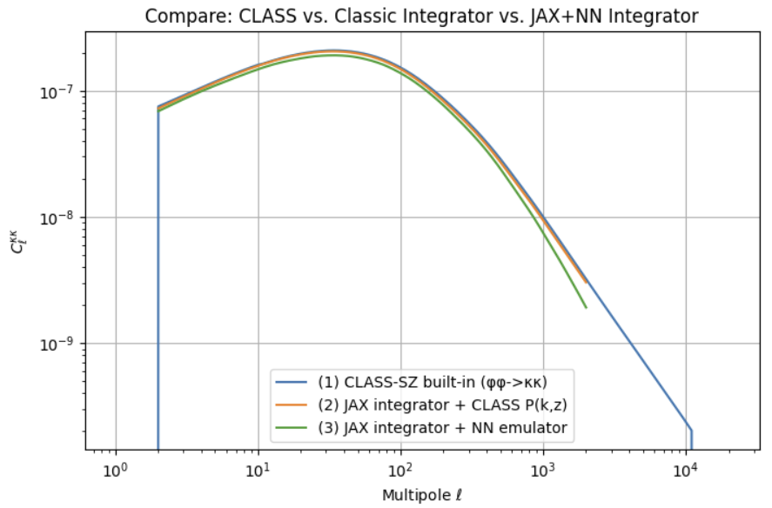

Log-Lin Grid method

Architecture: [256]

Interpolation:

Emulated the lnk’s at all 50 z’s for each set of input parameters (with 1 emulation), then interpolated between the z’s to find the exact lnk at the required z (only tested between z=10^-5 and 5)

Time to calculate: 0.01852400644995214 +- 0.0032485969083548114 seconds

The mean percentage difference between the interpolated value and true value: 0.7744554281234741 +- 0.5512167811393738%

Limber Integral:

Time to calculate: 0.09133723515999236+-0.0299070709323026 seconds

r^2 between CLASS P and NN emulator = 0.9999696632930826

